NAME : MOHAMMED FAZIL
BATCH : DAF9
ASSIGNEMENT 6: Clauses AND JOINS

- Distinct Values:
⦿ a query to retrieve distinct salaries from the Employees table.

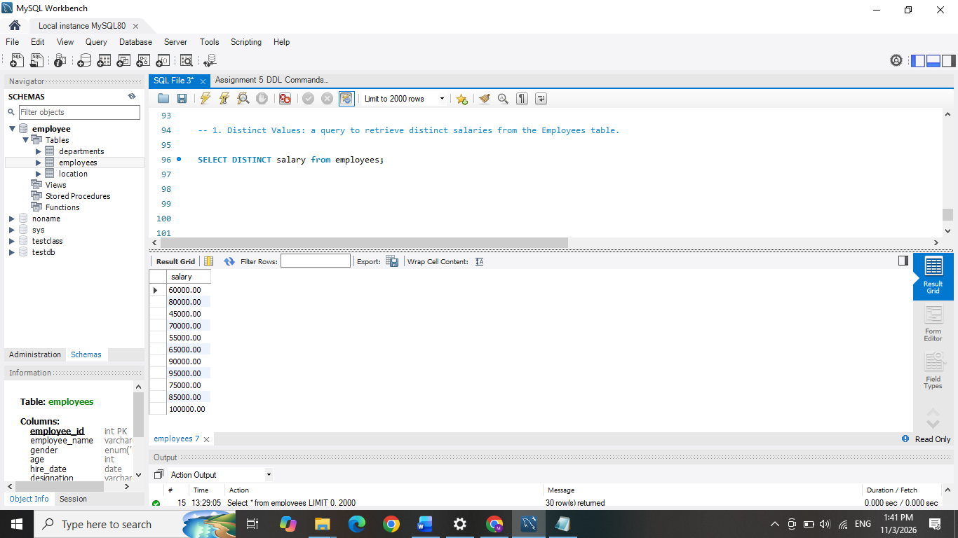
- Alias (AS):
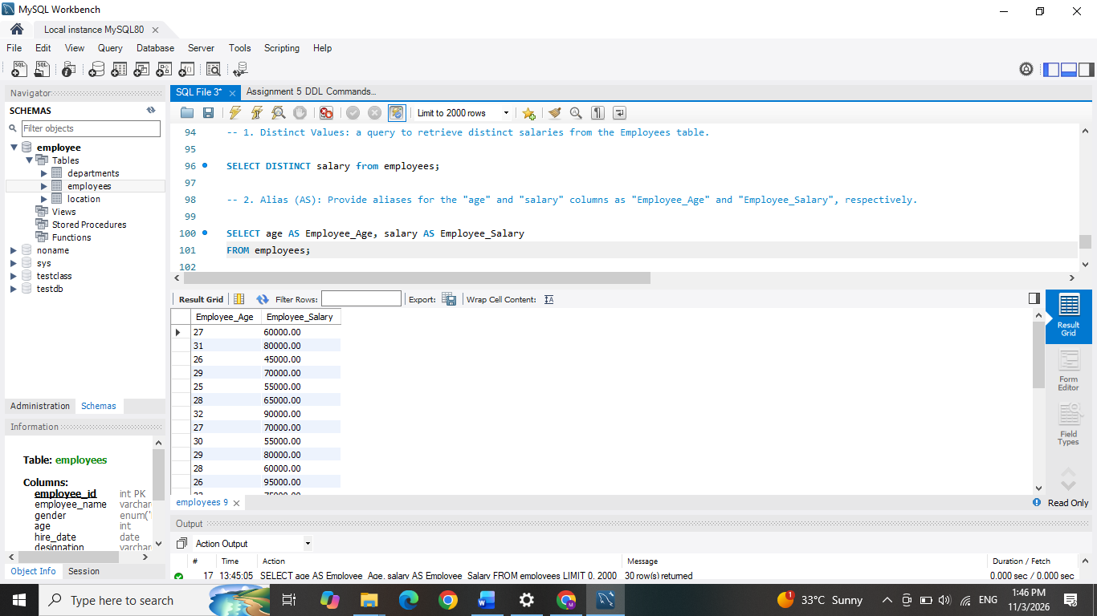
⦿ Provide aliases for the "age" and "salary" columns as "Employee_Age" and "Employee_Salary", respectively.
- Where Clause & Operators:
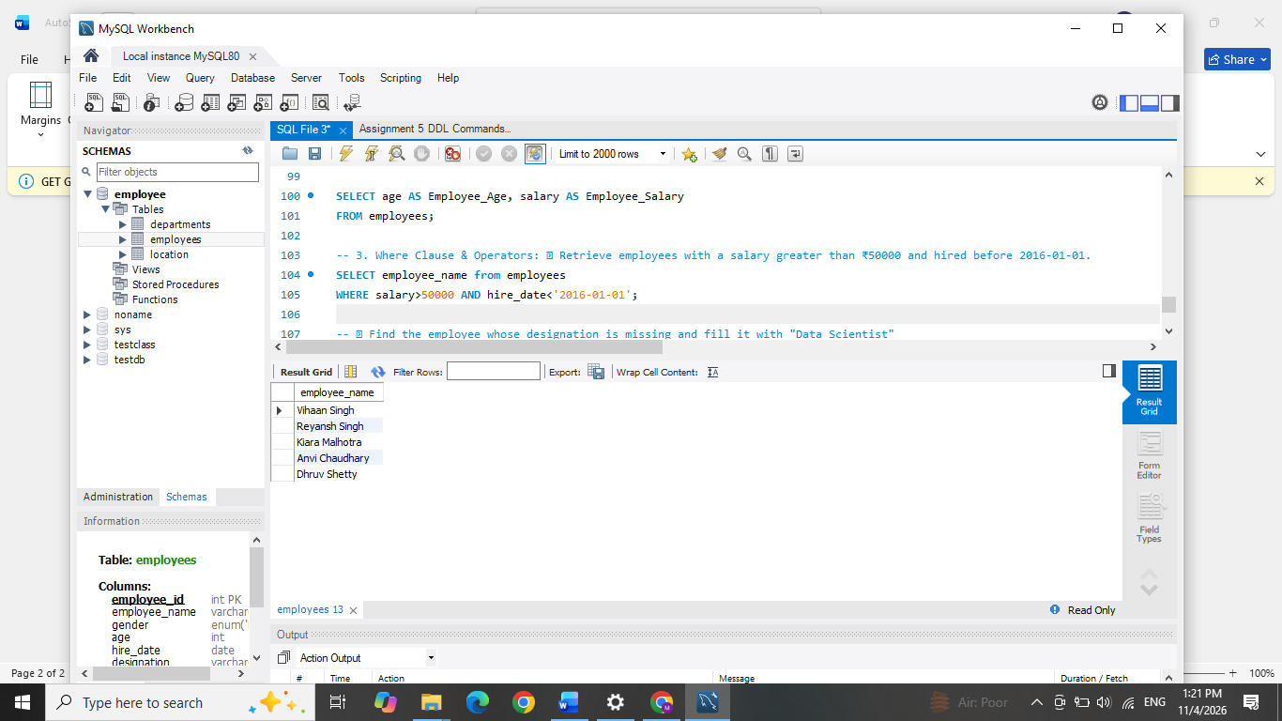
⦿ Retrieve employees with a salary greater than ₹50000 and hired before 2016-01-01.

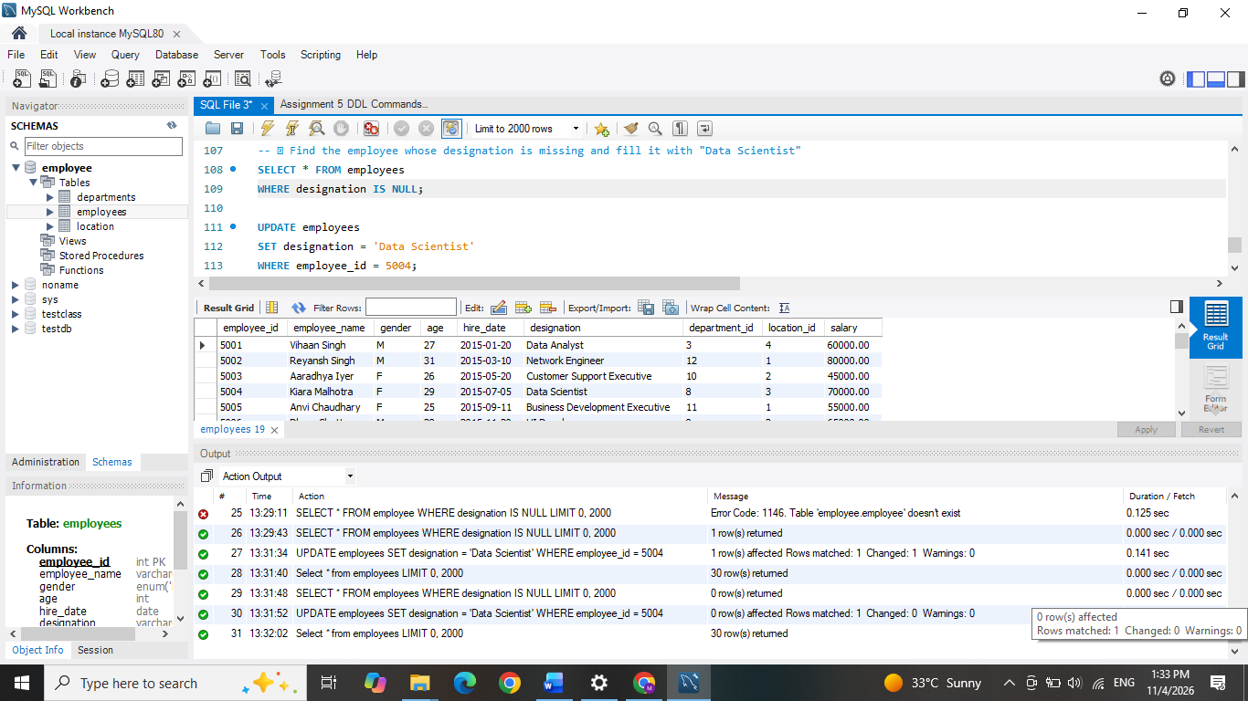
⦿ Find the employee whose designation is missing and fill it with "Data Scientist".
Sorting and Grouping Data:
- ORDER BY:
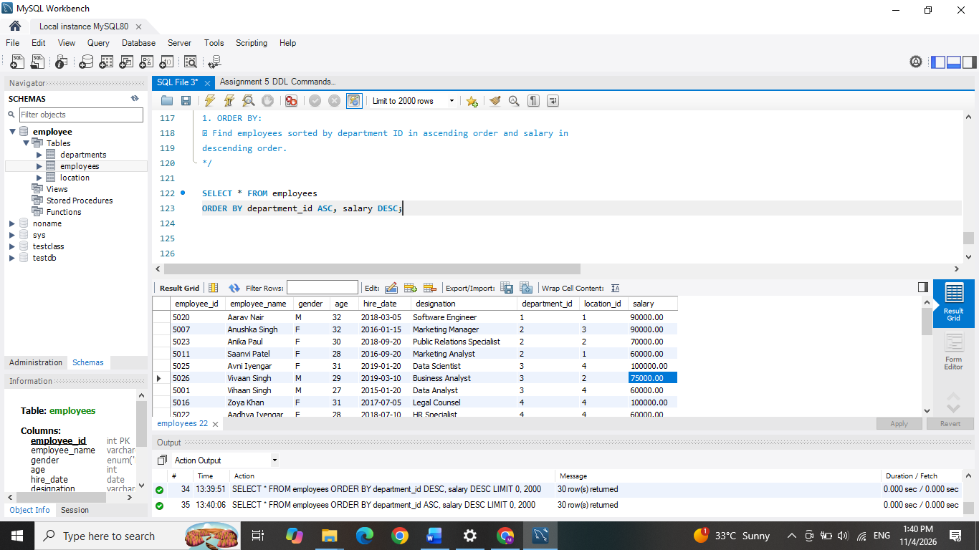
⦿ Find employees sorted by department ID in ascending order and salary in descending order.

- LIMIT:
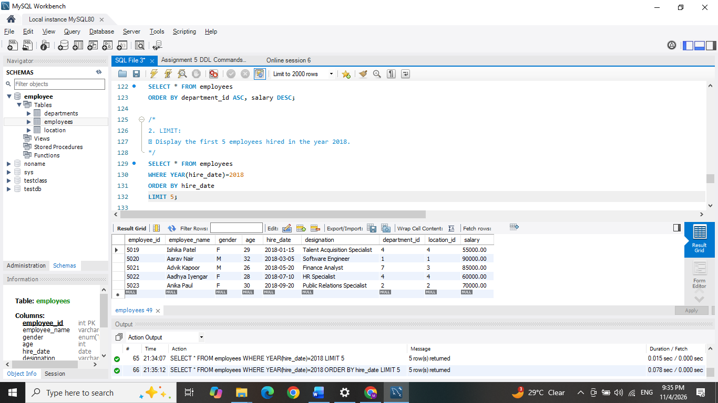
⦿ Display the first 5 employees hired in the year 2018.
3. Aggregate Functions:
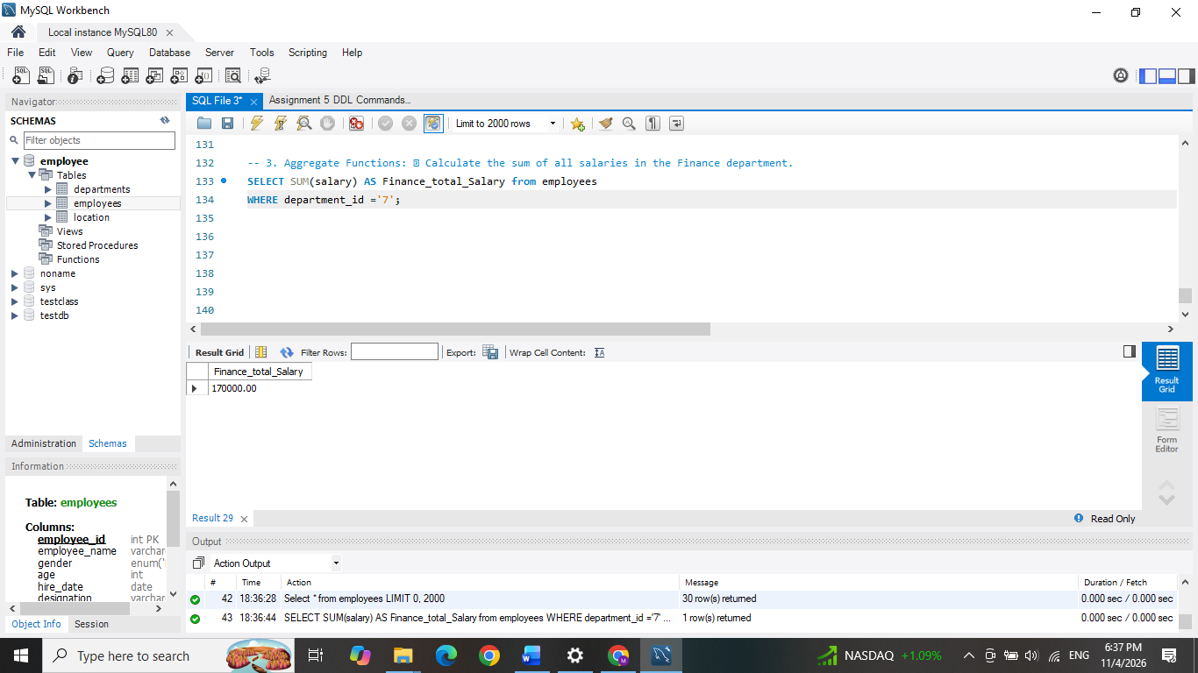
⦿ Calculate the sum of all salaries in the Finance department.

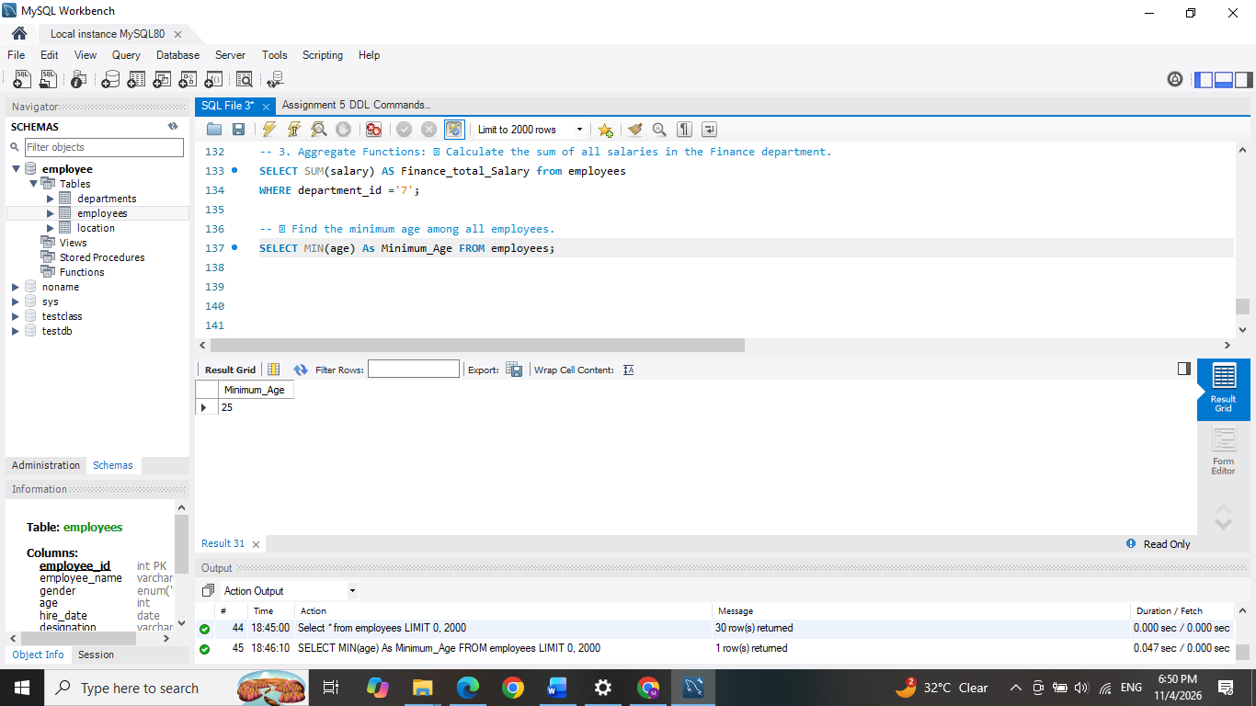
⦿ Find the minimum age among all employees.

4. GROUP BY:
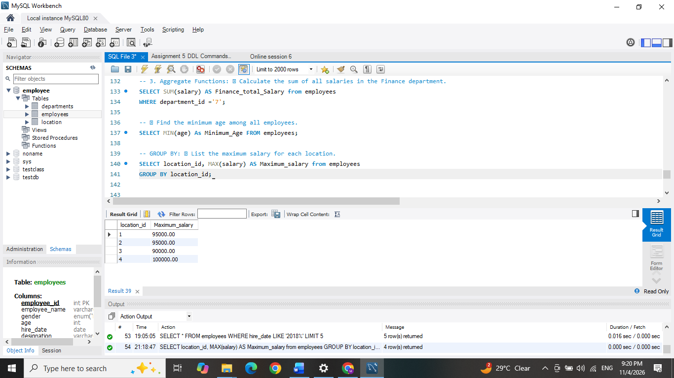
⦿ List the maximum salary for each location.

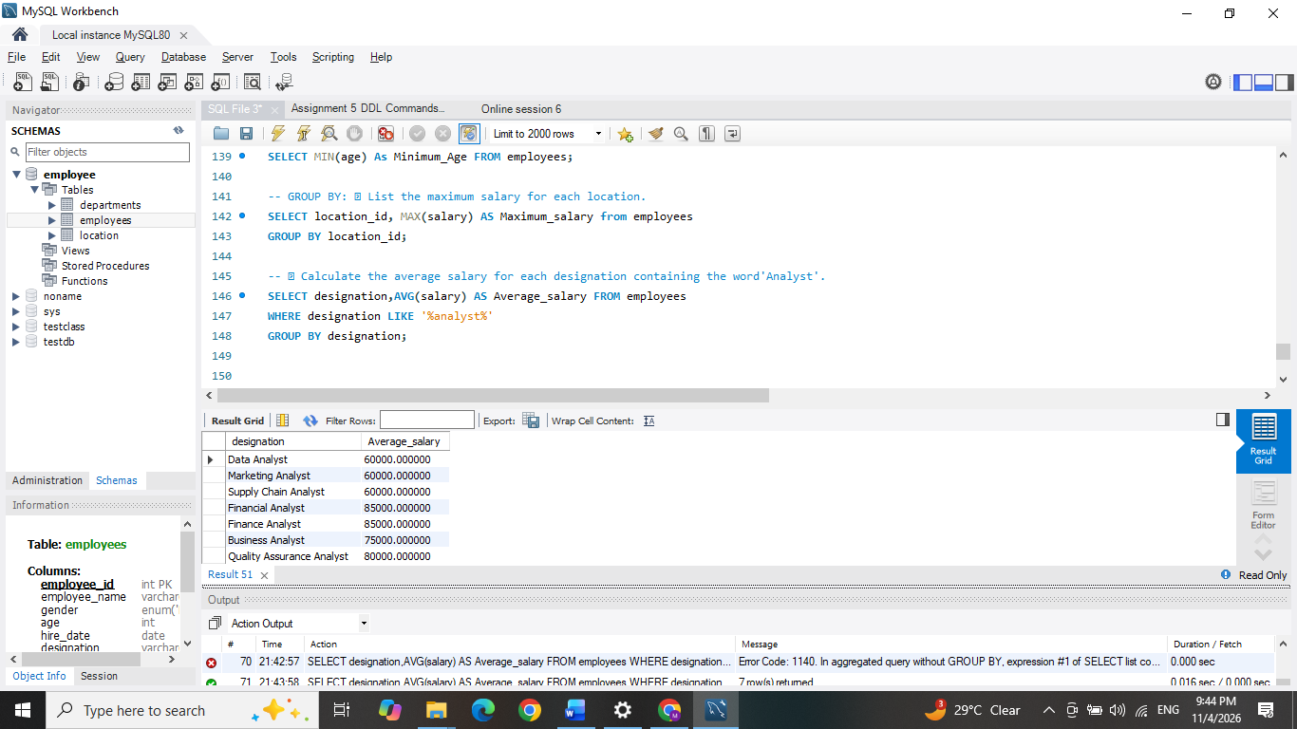
⦿ Calculate the average salary for each designation containing the word 'Analyst'.

- HAVING:
⦿ Find departments with less than 3 employees. 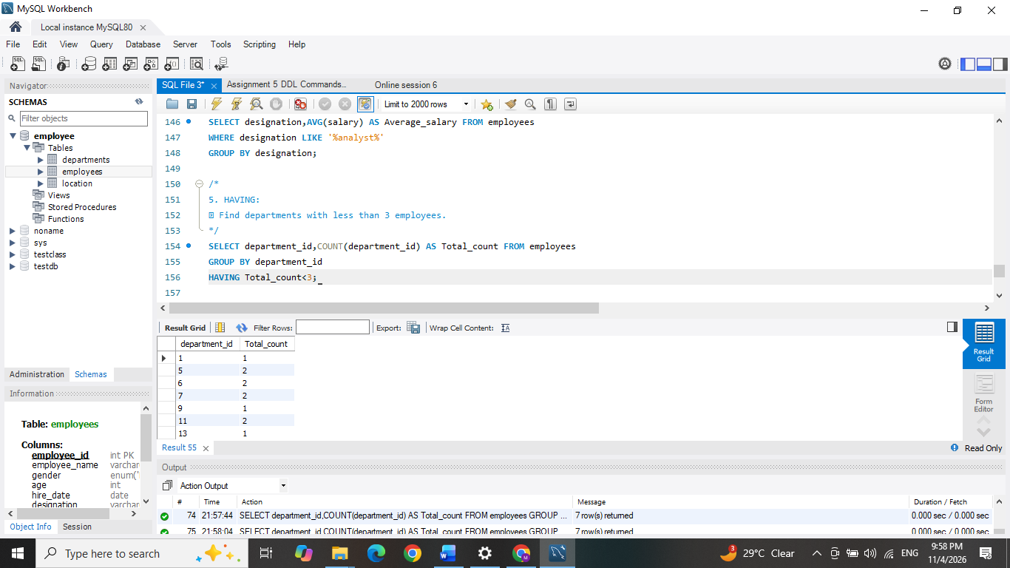
⦿ Find locations with female employees whose average age is below 30

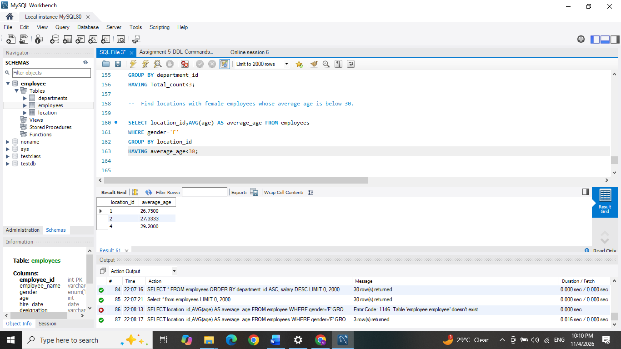
Joins: 1. Inner Join:
⦿ List employee names, their designations, and department names where employees are assigned to a department.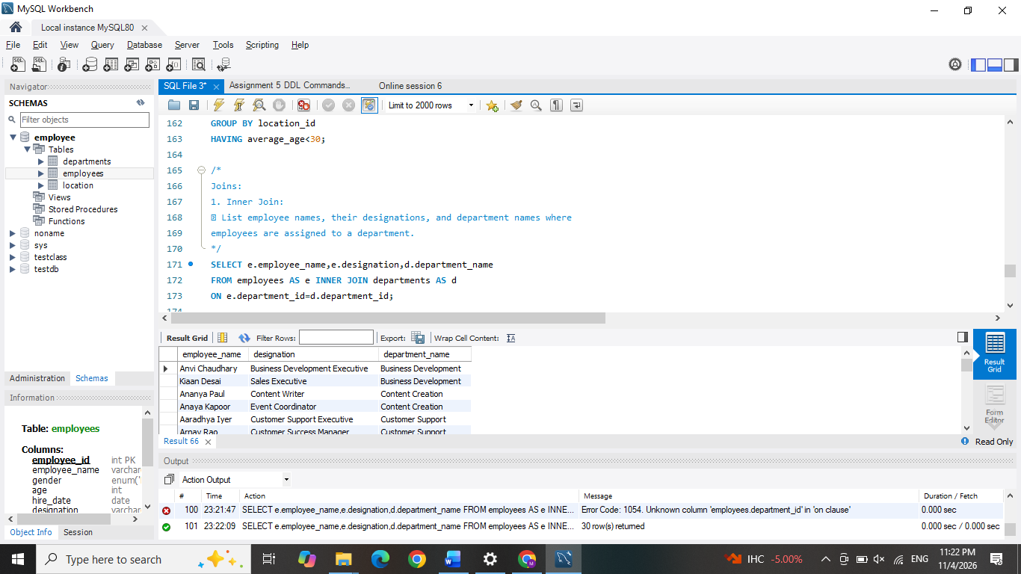

- Left Join:
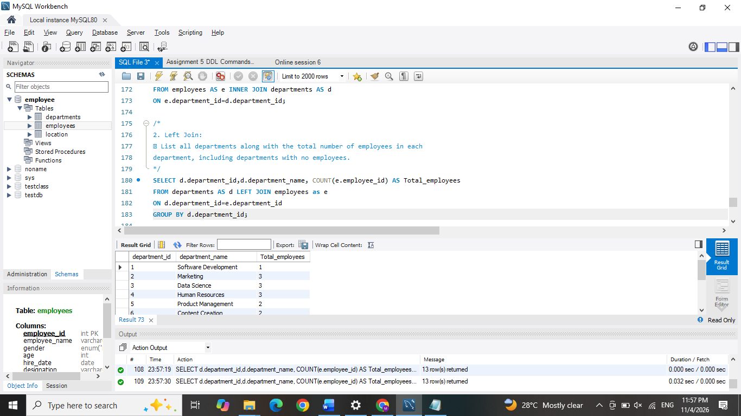
⦿ List all departments along with the total number of employees in each department, including departments with no employees.
3. Right Join:
⦿ Display all locations along with the names of employees assigned to each location. If no employees are assigned to a location, display NULL for employee name.


